Class in Java

eat() run() eat() fly() start() stop()
Vehicle
Animal
Bird

Dog Cat Sparrow Peacock Car Jeap

- Class is a set of object which shares common characteristics/ behavior and common properties/ attributes.
- Class is not a real world entity. It is just a template or blueprint or prototype from which objects are created.
- Class does not occupy memory.
- Class is a group of variables of different data types and group of methods.
A class in java can contain:
- data member
- method
- constructor
- nested class and
- interface
Syntax to declare a class:
access_modifier class<class_name>
{
data member;
method;
constructor;
nested class;
interface;
}
Eg:
- Animal
- Student
- Bird
- Vehicle
- Company etc

class Student{
int id;//data member (also instance variable)
String name; //data member (also instance variable)

public static void main(String args[])
{
Student s1=new Student();//creating an object of Student
System.out.println(s1.id);
System.out.println(s1.name);
}
}

Instance variable in Java
A variable that is created inside the class but outside the method is known as instance variable.Instance variable doesn't get memory at compile time.It gets memory at runtime when object (instance) is created.That is why, it is known as instance variable.
Syntax:
data_type variable_name;
eg:
int id;

Method in Java
- In java, a method is like function i.e. used to expose behavior of an object.
- Method is a set of codes that perform a particular task.

Syntax to declare a method:
<access_modifier> <return_type> <method_name>( list_of_parameters)
{
//body
}

Advantage of Method
- Code Reusability
- Code Optimization
Object
- Object is a real world entity with some attributes, behavior and unique identity.
- Object occupies memory.
- Object is an instance of a CLASS

Object consists of:-
- Identity
- Attribute
- Identity
Eg: Object Dog
Identity | Attribute | Behaviors/Method
Dog | - id  - bread  - age  - color | - eat  - run  - bark

eat() run() eat() fly() start() stop()
Vehicle
Animal
Bird

Dog Cat Sparrow Peacock Car Jeap

Syntax for creating an object:
<class_name> <object_name>=new <class_name>();
Eg:
Animal dog=new Animal ();

Syntax for invoking a method:
<object_name>.<method_name>();
Eg:
dog.eat();
dog.run();

new keyword
The new keyword is used to allocate memory at runtime.

Example of Object and class that maintains the records of students
class Student{
int rollno;
String name;
void setValue(int r, String n){
rollno=r;
name=n;
}
void display ()
{
System.out.println(rollno+" \t "+name);
}
public static void main(String args[]){
Student s1=new Student();
Student s2=new Student();
s1. setValue (111,"Karan");
s2. setValue (222,"Aryan");
s1.display();
s2.display(); }}
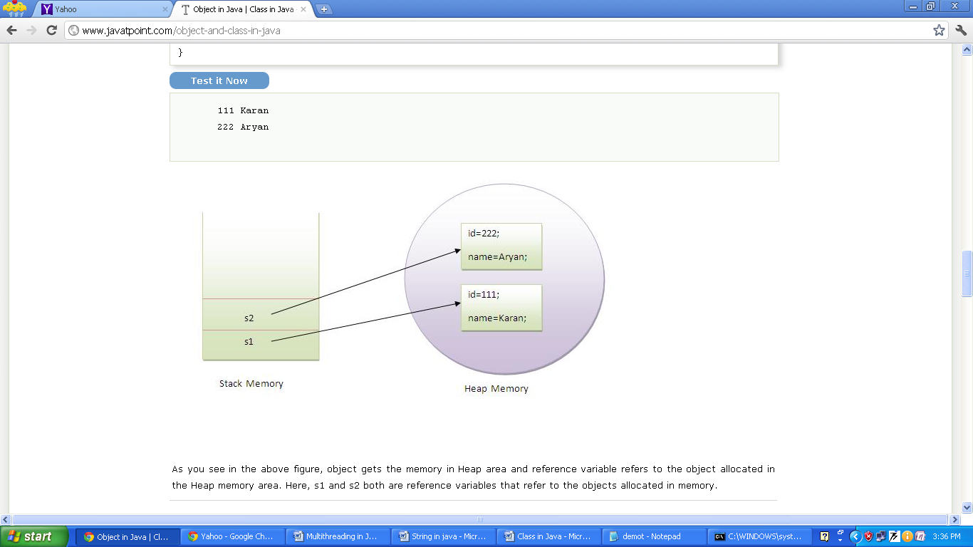

As you see in the given figure, object gets the memory in Heap area and reference variable ( i.e s1 and s2 ) gets memory in STACK area. Reference variable refers to the object allocated in the Heap memory area i.e. Reference variable just holds the memory address of the object (in the heap). Here, s1 and s2 both are reference variables that is refer to the objects allocated in memory.
In short, object is an instance of a class and reference (variable) points out to the object created in the heap area.

Anonymous object
- Anonymous simply means nameless.
- An object that has no reference is known as anonymous object.
- If you have to use an object only once, anonymous object is a good approach.
Eg:
class Calculation{
void fact(int n){
int fact=1;
for(int i=1;i<=n;i++){
fact=fact*i;
}
System.out.println("factorial is "+fact);
}
public static void main(String args[]){
new Calculation().fact(5);//calling method with annonymous object
}
}

Creating multiple objects by one type only
We can create multiple objects by one type only as we do in case of primitives.

Rectangle r1=new Rectangle(),r2=new Rectangle(); //creating two objects
class Rectangle{
int length;
int width;
void setValue(intl,int w){
length=l;
width=w;
}

void calculateArea(){System.out.println(length*width);}

public static void main(String args[]){
Rectangle r1=new Rectangle(),r2=new Rectangle();//creating two objects
r1. setValue (11,5);
r2. setValue (3,15);
r1.calculateArea();
r2.calculateArea();
}
}

Q: Develop a Java program to accept Student details as RollNumber, Name and Fee from the user and print the same.

(A) class Student {
int rno;
String sname;
double fee;
BufferedReader br=new BufferedReader(new InputStreamReader(System.in));
public void set_data()
{
try{
System.out.println("Enter the Roll Number:");
rno=Integer.valueOf(br.readLine());
System.out.println("Enter the Name:");
sname=br.readLine();
System.out.println("Enter the Fee:");
fee=Double.parseDouble(br.readLine());
}catch(Exception ex){ex.printStackTrace();} }

public void display()
{
System.out.println(rno+"\t"+sname+"\t"+fee);
}
public static void main(String args[])
{
try{
Student s=new Student();
s.set_data();
s.display();
}catch(Exception ex){ex.printStackTrace();}
}
}

(B)
import java.io.*;
import java.util.*;
class Student1 {
int rno;
String sname;
double fee;
Scanner scan=new Scanner(System.in);
Scanner scan1=new Scanner(System.in);
public void set_data()
{
try{
System.out.println("Enter the Roll Number:");
rno=scan.nextInt();
scan.nextLine();
System.out.println("Enter the Name:");
sname=scan1.nextLine();
System.out.println("Enter the Fee:");
fee=scan.nextDouble();
}catch(Exception ex){ex.printStackTrace();}
}

public void display()
{
System.out.println(rno+"\t"+sname+"\t"+fee);
}
public static void main(String args[])
{
try{
Student1 s=new Student1();
s.set_data();
s.display();
}catch(Exception ex){ex.printStackTrace();}
}
}
import java.util.*;
class lsearch
{

int i,sno,no,flag=0;
int a[];

public void set_data()
{

Scanner scan=new Scanner(System.in);
System.out.println("Enter the size of the array:");
no=scan.nextInt();
a=new int[no];
System.out.println("Enter the array elements:");
for(i=0;i<no;i++)
a[i]=scan.nextInt();

System.out.println("Enter the number to be search:");
sno=scan.nextInt();

}

public void check()
{
set_data();
for(i=0;i<no;i++)
{
if(a[i]==sno)
{
flag=1;
break;
}

}

if(flag==1)
System.out.println("Number found.");
else
System.out.println("Number not found.");

}

public static void main(String args[])
{
lsearch l=new lsearch();
l.check();

}}

Can you save a java source file by other name than the class name?
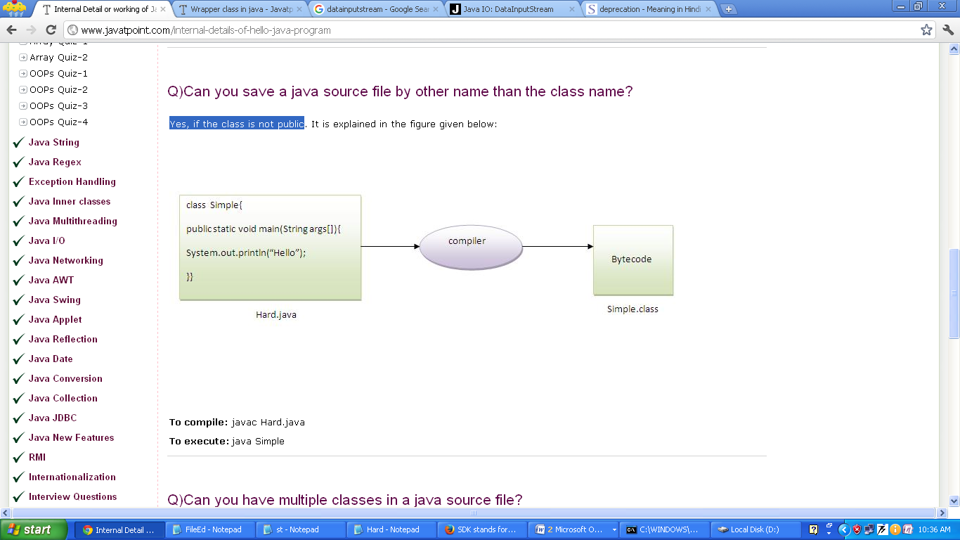
Yes, if the class is not public

Can you have multiple classes in a java source file?
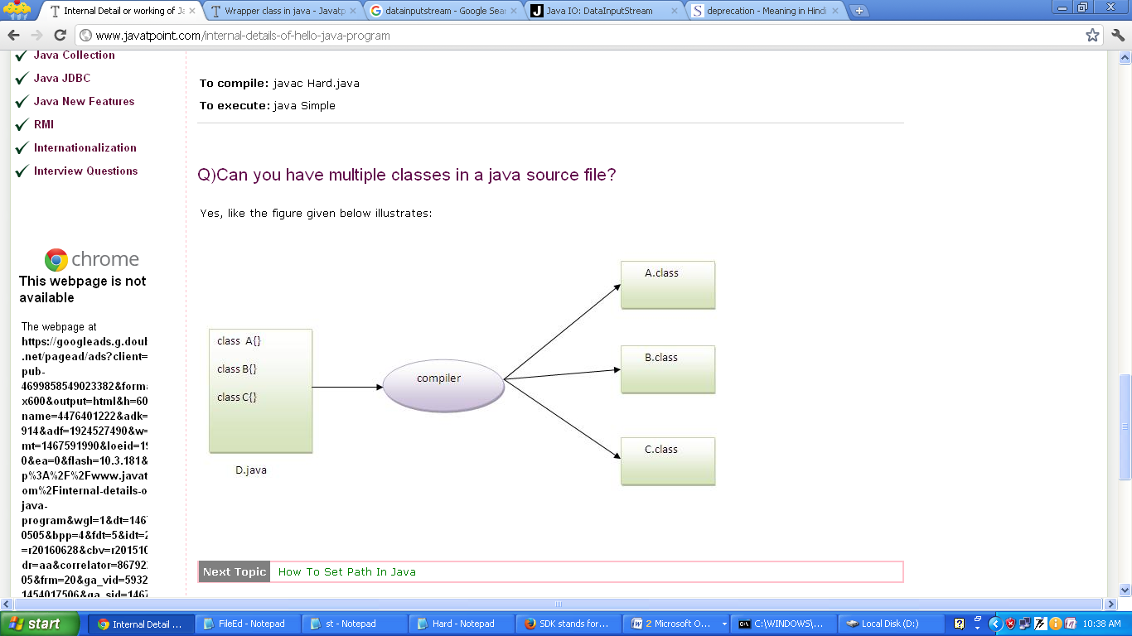
Yes.

Q: Develop a java program to implement the concept of STACK.
import java.io.*;

public class Stack {
final int MAX=5;
int stk[]=new int[MAX];
int top=-1;
boolean isFull()
{
if(top==MAX-1)
return true;
else
return false;
}
boolean isEmpty()
{
if(top==-1)
return true;
else
return false;
}
void push(int no)
{
if(isFull()==true)
{
System.out.println("STACK IS OVERFLOW");
return;
}
++top;
stk[top]=no;
}
int pop()
{
if(isEmpty()==true)
{
System.out.println("STACK IS UNDERFLOW");
return 0;
}
int x=stk[top];
--top;
return x;

}

void display()
{
if(isEmpty()==true)
{
System.out.println("STACK IS UNDERFLOW");
return;
}
int i;
for(i=top;i>=0;i--)
{
System.out.println("");
System.out.print(stk[i]+"\t");
}
}
void peek()
{
if(isEmpty()==true)
{
System.out.println("STACK IS UNDERFLOW");
return;
}
System.out.println(stk[top]);
}

public static void main(String args[]) throws IOException
{
int ch;
int x;
Stack s=new Stack();

BufferedReader br=new BufferedReader(new InputStreamReader(System.in));
while(true)
{
System.out.println("1]PUSH\t2]POP\t3]PEEP\t4]DISPLAY\t5]EXIT\n");
System.out.println("Enter Your Choice?");
ch=Integer.valueOf(br.readLine());
switch(ch)
{
case 1:
System.out.println("Enter the Number:");
x=Integer.valueOf(br.readLine());
s.push(x);

break;
case 2:
x=s.pop();
if(x!=0)
System.out.println(x+"\t element is poped"); break;
case 3:
s.peek(); break;
case 4:
s.display(); break;
case 5:
System.exit(0);
}

}
}
}

Q. Write a CLASS named Employee with Employee_id, basic_Salary, TA, DA, HRA, Gross_Salary (GS) as a attribute and setData() method to assign the data. calculate_Salary() method to calculate GrossSalary and display() method to print the on the screen.
TA= 15% of salary
DA=12% of salary
HRA=15% of salary
Gross Salary= basic_Salary+DA+HRA+TA
Array of class object

Arrays of variables of type “CLASS” is known as array of objects.

Q: Develop a Java program to accept ‘N’ numbers of student from the user and print the same.
import java.io.*;

public class Student {
int rno;
String sname;
double fee;
BufferedReader br=new BufferedReader(new InputStreamReader(System.in));
public void set_data()
{
try{
System.out.println("Enter the Roll Number:");
rno=Integer.valueOf(br.readLine());
System.out.println("Enter the Name:");
sname=br.readLine();
System.out.println("Enter the Fee:");
fee=Integer.parseInt(br.readLine());
}catch(Exception ex){ex.printStackTrace();}
}

public void display()
{
System.out.println(rno+"\t"+sname+"\t"+fee);
}
public static void main(String args[])
{
try{
Student s[]=new Student[100];
BufferedReader br=new BufferedReader(new nputStreamReader(System.in));
int no,i;

System.out.println("Enter the Number of Student:");
no=Integer.parseInt(br.readLine());
System.out.println("Enter the Student Details one by one:");
for(i=0;i<no;i++)
{
s[i]=new Student();
s[i].set_data();
}

for(i=0;i<no;i++)
{
s[i].display();
}

System.out.println("STUDENT RECORD");
System.out.println("-----------------------------------");
for(i=0;i<no;i++)
{
s[i].display();
}

}catch(Exception ex){ex.printStackTrace();}
}
}

Q: Write a Java program to accept the 50 Item details/records as ItemId, ItemName, and ItemPrice from the user. Find out the average price of the Item.
Q: Write a Java program to accept the “N” book record/details as BookId, BookName, AuthorName and BookPrice from the user. Print the record of the entire Book having price greater than the average price of the Book.
Q: Write a Java program to accept the “N” Student records/details as RollNo, Name, AuthorName, PercentageMarks from the user. Find out the topper student detail/record.
Q: Develop a Java program for Student class with following attribute such as RollNo, Student Name and Fee. Program should sort and display the record of Student in ascending order of their RollNo.

Passing Object as a parameter to the Method

Q: Write a java program to add two Complex number using classes

import java.io.*;
public class Complex {
int real,imag;
void setValue()
{
try{
BufferedReader br=new BufferedReader(new InputStreamReader(System.in));
System.out.println("Enter the real number: ");
real=Integer.parseInt(br.readLine());
System.out.println("Enter the imaginary number: ");
imag=Integer.parseInt(br.readLine());
}catch(Exception ex){ex.printStackTrace();}
}

//method to add two complex numbers
void add(Complex c1,Complex c2)
{
real=c1.real+c2.real;
imag=c1.imag+c2.imag;
}

//method to display complex numbers
void display()
{
System.out.println(real+"\t"+imag);
}

public static void main(String args[])
{
Complex t1=new Complex();
Complex t2=new Complex();
Complex t3=new Complex();
t1.setValue();
t2.setValue();

t1.display();
t2.display();

t3.add(t1, t2);
t3.display();
}
}

Q. Create a complex number class in Java. The class should have a method to add, subtract, and multiply two complex numbers.

Q: Write a java program to add two times by passing object as a function argument.

Return Object to the calling Method
Q: Write a java program to add two Complex number using classes

import java.io.*;
public class Complex {
int real,imag;
void setValue()
{
try{
BufferedReader br=new BufferedReader(new InputStreamReader(System.in));
System.out.println("Enter the real number: ");
real=Integer.parseInt(br.readLine());
System.out.println("Enter the imaginary number: ");
imag=Integer.parseInt(br.readLine());
}catch(Exception ex){ex.printStackTrace();}
}

//method to add two complex numbers
Complex add(Complex c1,Complex c2)
{
Complex temp=new Complex();
temp.real=c1.real+c2.real;
temp.imag=c1.imag+c2.imag;
return temp;
}

//method to display complex numbers
void display()
{
System.out.println(real+"\t"+imag);
}

public static void main(String args[])
{
Complex t1=new Complex();
Complex t2=new Complex();
Complex t3=new Complex();
t1.setValue();
t2.setValue();

t1.display();
t2.display();

t3=t3.add(t1, t2);
t3.display(); }
}

Q. Create a complex number class in Java. The class should have a method to add, subtract, and multiply two complex numbers, and return the real and imaginary parts.

Passing array object as parameter to the Method

Q: Develop a Java program for Student class with following attribute such as RollNo, Student Name and Fee. Program should sort and display the list of Student in ascending order of their RollNo using object as a function argument.
import java.io.*;
public class Student {
int rno;
String sname;
double fee;
BufferedReader br=new BufferedReader(new InputStreamReader(System.in));
public void set_data()
{
try{
System.out.println("Enter the Roll Number:");
rno=Integer.valueOf(br.readLine());
System.out.println("Enter the Name:");
sname=br.readLine();
System.out.println("Enter the Fee:");
fee=Integer.parseInt(br.readLine());
}catch(Exception ex){ex.printStackTrace();}
}

public void display()
{
System.out.println(rno+"\t"+sname+"\t"+fee);
}

public void ssort(int no,Student x[])
{
int i,j;
Student temp;
for(i=0;i<no-1;i++)
{
for(j=i+1;j<no;j++)
{
if(x[i].rno>x[j].rno)
{
temp=x[i];
x[i]=x[j];
x[j]=temp;
}
}
}
}

public static void main(String args[])
{
try{
Student s[]=new Student[100];
BufferedReader br=new BufferedReader(new InputStreamReader(System.in));
int no,i;

System.out.println("Enter the Number of Student:");
no=Integer.parseInt(br.readLine());
System.out.println("Enter the Student Details one by one:");
for(i=0;i<no;i++)
{
s[i]=new Student();
s[i].set_data();
}

for(i=0;i<no;i++)
{
s[i].display();
}

s[0].ssort(no, s);

System.out.println("AFTER SOTING STUDENT RECORD");
System.out.println("-----------------------------------");
for(i=0;i<no;i++)
{
s[i].display();
}

}catch(Exception ex){ex.printStackTrace();}
}
}

